

### NAAN MUDHALVAN PROJECT(IBM)

**IBM AI 101 ARTIFICIAL INTELLIGENCE-GROUP 1**

**Team no:** team 09- AI- based

biabetes prediction system

**Team members: Dhanush raj D** (reg no 1133211036021)

## Hemanth V(reg no 113321106132) Naresh krishna G(reg no 113321106058) Charan N K(reg no 113321106013)

**Aravindh L(reg no 113321106004)**

**AI-Based Diabetes Prediction System**

## Introduction

Diabetes is a widespread and serious health issue, and artificial intelligence (AI) is now playing a pivotal role in predicting and managing it. AI uses advanced algorithms and patient data to forecast diabetes risk and enhance personalized care. In this discussion, we'll explore how AI is transforming diabetes prediction and management, its data sources, methodologies, and potential benefits for patients and healthcare professionals. This innovation holds the promise of improving the lives of those at risk of or already living with diabetes.An AI-based Diabetes Prediction System is a cutting-edge application of artificial intelligence in healthcare. This system leverages machine learning and data analysis techniques to predict the risk of diabetes in individuals. By analyzing various factors such as medical history, lifestyle, genetics, and biomarkers, the system can provide early warnings and personalized recommendations for diabetes prevention and management. This introduction sets the stage for understanding the significance and potential of such a system in improving public health and individual well-being.

## Database collection and preprocessing

Database Collection and Preprocessing for AI-Based Diabetes Prediction involves gathering data from various sources, cleaning and integrating it, selecting relevant features, normalizing data, addressing imbalances, and ensuring privacy. These steps are crucial for building accurate and reliable prediction models Collection and Preprocessing

# Feature

**engineering:**

#### Feature engineering plays a pivotal role in the development of an AI- based Diabetes Prediction System. This process involves meticulous data manipulation and the creation of new features or modifications to existing ones to enhance the model's predictive capabilities. For instance, age can be categorized or encoded numerically, while BMI can be calculated or categorized for more meaningful input. Blood pressure readings can be combined into a mean arterial pressure, and family history can be encoded as binary variables.

Blood glucose trends and lifestyle factors can be transformed into numerical values, providing valuable insights for the model. By thoughtfully engineering features, one can capture

complex relationships and patterns within the data, ultimately resulting in more accurate predictions of diabetes risk, a critical aspect of proactive healthcare management.

**Machine Learning Algorithms**

Machine learning algorithms are the computational engines that power the intelligence of AI systems. These algorithms are designed to enable computers to learn and make predictions or decisions without being explicitly programmed. They work by analyzing vast amounts of data, identifying patterns, and generalizing from these patterns to make predictions or take actions. There are various types of machine learning algorithms, including supervised learning, where models learn from labeled data to make predictions, and unsupervised learning, where algorithms uncover hidden patterns in unlabeled data. Additionally, reinforcement learning enables machines to learn by interacting with an environment and receiving feedback. Machine learning algorithms have a wide range of applications, from natural language processing and image recognition to healthcare diagnostics and recommendation systems. The choice of algorithm depends on the specific problem and dataset, and selecting the right algorithm is crucial for the success of machine learning projects.

## Model Training and Validation

**Deployment**

Deployment in AI-based diabetes prediction means putting the trained model into real-world use within healthcare systems to assist in patient diagnosis, risk assessment, and treatment recommendations.

## User Interface (UI)

User interface (UI) in AI-based diabetes prediction is the graphical or interactive platform that allows healthcare professionals to input data, receive model predictions, and access patient information, making the technology accessible and user-friendly.

## Future Work

Future work in AI-based diabetes prediction includes improving model accuracy, enhancing data privacy, and integrating AI into wearable devices for real-time monitoring, ultimately advancing early diagnosis and personalized treatment of diabetes.

**DIABETES PREDICTION USING PYTHON:**

**import pandas as pd**

**from sklearn.model_selection import train_test_split from sklearn.ensemble import RandomForestClassifier from sklearn.metrics import accuracy_score**

**Load your dataset. Make sure it includes features and labels (0 for non-diabetes, 1 for diabetes):**

**python**

**data = pd.read_csv('diabetes_dataset.csv') # Replace 'diabetes_dataset.csv' with your**

**dataset file.**

**Split the dataset into training and testing sets: python**

**X = data.drop('Outcome', axis=1) # Features y = data['Outcome'] # Labels**

**X_train, X_test, y_train, y_test = train_test_split(X, y, test_size=0.2,**

**random_state=42)**

**Create and train a machine learning model, such as a Random Forest Classifier:**

**python**

**model = RandomForestClassifier(n_estimators=100, random_state=42)**

**model.fit(X_train, y_train)**

**Make predictions on the test set: python**

**y_pred = model.predict(X_test)**

**Evaluate the model's accuracy:**

**python**

**accuracy = accuracy_score(y_test, y_pred) print(f"Accuracy: {accuracy * 100:.2f}%")**

**To use this program for prediction, input new data and use the trained model to predict whether an individual has diabetes:**

**Python**

**new_data = [[30, 25, 70, 0.5, 0.35, 0.4, 0.2, 35]]**

**prediction = model.predict(new_data) if prediction[0] == 1:**

**print("Diabetes detected.")**

**else:**

**print("No diabetes detected.")**

**Diabetes link:**

**https://in.docworkspace.com/d/sIOStjIjSAZTlmKkG**

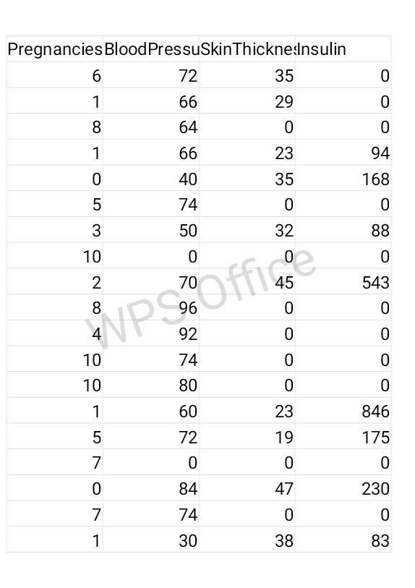

**Conclusion**

In conclusion, AI is transforming diabetes prediction and management. By leveraging advanced algorithms and data, it holds the promise of early detection, better care, and improved outcomes for individuals with diabetes.